PHPP and LCAQuick - an integrated energy / Life Cycle Assessment toolset
Jason Quinn, Sustainable Engineering Ltd.
76 Virginia Road, Whanganui, New Zealand
Phone: +64 (0) 6 888 6018; Jason@SustainableEngineering.co.nz

Brian Berg, BRANZ Ltd.
1222 Moonshine Road, Porirua, New Zealand
Phone: +64 (0) 4 237 1176; Brian.berg@branz.co.nz
Demonstration of an integration between the Microsoft Excel based LCAQuick tool and the Passive House Planning Package (PHPP) which allows quick calculation of the Life Cycle Assessment (LCA) impacts as the PHPP inputs are changed. Through the integration with LCAQuick the potential trade-offs between greenhouse gas emissions (and other environmental indicators) as a result of achievement of different thermal performance levels, and the materials required to achieve these, are quantified and can be immediately seen. This allows the designer to use PHPP and LCAQuick to optimize the building to minimize energy and multiple environmental indicators simultaneously.
In this demonstration the primary question explored was at what point does it make sense from an LCA point of view (considering kgCO2e) to stop energy conservation via envelope changes (insulation layer thickness and window changes). Passive House is aimed at an economic optimum but the ecological optimum, even for a specific house built a specific way, will be different.
For two of the Certified Passive House buildings explored the ecological optimum measured in kgCO2e was not reached even at half the operational energy of the certification level of heating demand. In other words, even at half the energy consumption of the Passive House it would reduce the kgCO2e released over the life cycle of the building to keep adding insulation. For the SIP building in a warmer climate and more impactful insulation (XPS) the ecological optimum is near the Certified Passive House performance level.
  - LCA – Life Cycle Assessment
International building sustainability standards set out environmental and other indicators for calculation when undertaking building LCA. These are based on environmental impacts using Life Cycle Impact Assessment, and values for flows of energy and materials in the Life Cycle Inventory. ISO standards define what and how this evaluation is conducted to allow comparison across studies.
LCA is an environmental systems analysis and accounting tool for quantifying the inputs and outputs of an option, whether a product, service or organisation and relating these to potential environmental impacts. LCA is a systematic approach, where the system of interest comprises the operations that collectively produce the product or service being investigated. The system being assessed is linked to other industrial systems supplying and transporting inputs and carrying away outputs (Figure 1), all of which is considered within the assessment.
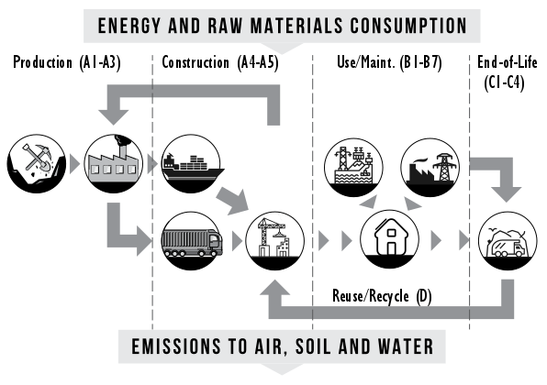
Figure 1: LCAQuick per EN 15978:2011 covers all life cycle stages for materials from extraction of resources through production (A1-A3), shipping to site and construction with wastage (A4-A5), building usage stage including operational and maintenance costs (B1-B7), end-of-life for building (C1-C4), and reuse/recycling benefits (D).
An LCA offers a clear and comprehensive picture of the flows of energy and materials through a system and gives a holistic and objective basis for comparisons. Results are presented in terms of the system function so that the value of the function can be balanced against the environmental effects with which it is associated.
The results of an LCA quantify the potential environmental impacts of a product or service over the life cycle, to help identify opportunities for improvement and to indicate more environmentally-preferable options, for example, through comparison of alternative building designs and energy conservation measures.
  - LCAQuick –what is it
LCAQuick is a New Zealand (NZ) specific whole-of-building whole-of-life LCA tool developed by BRANZ (as a free tool) to provide a resource for building designers to better understand what LCA is, what its outputs are, how to incorporate LCA into their existing workflows and how to use it in design to lower the environmental impact of buildings.
BRANZ has sought to make LCAQuick easy for building designers to use during early design. As such, embedded in the tool is a Life Cycle Impact Assessment (LCIA) database of common building materials, products and processes such as grid electricity. These are predefined and are reflective of NZ standard practices. The primary inputs building designers must enter into LCAQuick are those building designers can calculate themselves, e.g. building material quantities for the structure and envelope, energy model results and estimates for water consumption. As PHPP inputs are very similar and as both tools are Excel based, the linkage of these two tools will allow the designer to simultaneously calculate the energy impacts of building envelope changes and LCA impacts from the PHPP tool. The environmental indicators calculated are a subset of these appropriate for the initial design stage: Global warming (100 year); Stratospheric ozone depletion; Acidification; Tropospheric ozone formation; Eutrophication; Abiotic depletion - elements/fossil fuels; Primary energy total/non-renewable/renewable. This paper focusses on an assessment of global warming (100 year) or climate change.
LCIA data for NZ specific materials and products is scarce. In the current absence of NZ specific data (for example, from published EPDs), generic data for products used in the structure and thermal envelope have been developed and externally reviewed for application (by BRANZ as part of LCAQuick development) during concept and preliminary design. The material impacts in LCAQuick are for NZ materials adjusted for material type & NZ travel distances based on a somewhat simplified market share inside NZ. Many papers covering the data used, methods and validation, as well as the Excel LCAQuick tool itself are available online at https://www.branz.co.nz/buildinglca
  - Comparison with other tools
Other building LCA tools such as eToolLCD are more comprehensive and more complicated than LCAQuick, for example they can adjust site travel distances and wastage rates for materials during construction. Different tools have different materials databases and impacts localized for their country. NZ is a small market and only LCAQuick and eToolLCD are setup with any sort of localized LCA databases for NZ. BRANZ, together with other international research organisations, is participating in an International Energy Agency research programme looking at the environmental impacts of buildings. As part of this work, specific buildings with defined material quantities and energy use are being assessed using national methodologies. Early findings, reported in [2019 Frischknecht et al.] indicate some higher embodied energy values for NZ materials and lower operational energy impacts, due to our smaller manufacturing volumes, large proportion of imports and the high fraction of renewable energy in our electrical supply. The primary implications of this are that the LCA conducted with LCAQuick would (again generally) be biased towards recommending lower materials impacts versus operational impacts.
  - Scope of the LCA
The intent of this study was to investigate the life cycle carbon impact of operational heating energy (module B6) reduction strategies, specifically increased thermal resistance of the building’s thermal envelope, and the additional building material impacts (modules A1-A5, B2, B4, C1-C4 & D) required to realise those reductions.
To achieve this, 3 different Passive House case studies were assessed, where only the building materials associated with the building’s thermal envelope were included. For clarity the following were excluded:
- Internal fitout, fittings, fixtures, and building services.
- The material impacts associated with Mechanical Ventilation with Heat Recovery (MVHR) system were also excluded.
Three Certified Passive House single family homes PHPP was imported into a variants file and modified so the performance varied from NZ code minimum construction (R1.9 walls for example) to half the PHPP heating demand for that certified passive house. These projects were selected to represent the three most common building construction methods we see in NZ for Passive House construction (see Figure 2).
Table 1: Summary of typical wall construction system. Note fixings excluded.
Exterior finishes | Paint (exterior), water-borne, for timber (2 coats / m²)  Paint (exterior), water-borne, primer/sealer (1 coat / m²)
Exterior cladding | Timber weatherboards, soft wood, dressed kiln-dried, all profiles [from sustainable forest management practices]
 | Membrane, building wrap, polyethylene (PE)
Wall structure/insulation | Timber wall framing, soft wood, dressed kiln-dried sections [from sustainable forest management practices]  Insulation (90 mm wall), Pink® Batts® Ultra® R2.8 Wall (glass wool)
Interior cladding | Plasterboard (GIB® standard 10 mm)
Interior finishes | Paint, water-based acrylic primer/undercoat (Dulux acrylic sealer undercoat) (1 coat / m²)  Paint, water-borne, walls (Dulux Wash&Wear® low sheen - vivid white) (2 coats / m²)

Figure 2: Constructions for buildings examined: (left) timber framed on top insulated concrete slab with metal roofing on truss roof; Insulated Concrete Form (ICF) walls on insulated concrete slab with metal roofing on timber rafter roof; Structurally Insulated Panel (SIP) walls on insulated concrete slab with metal roofing on truss roof.

  - Results
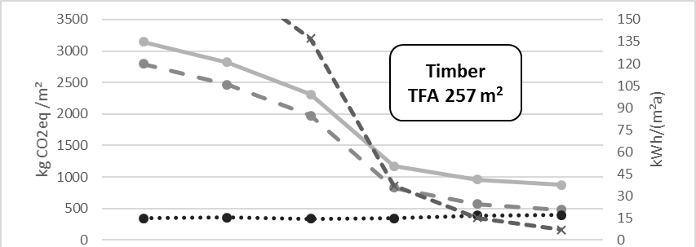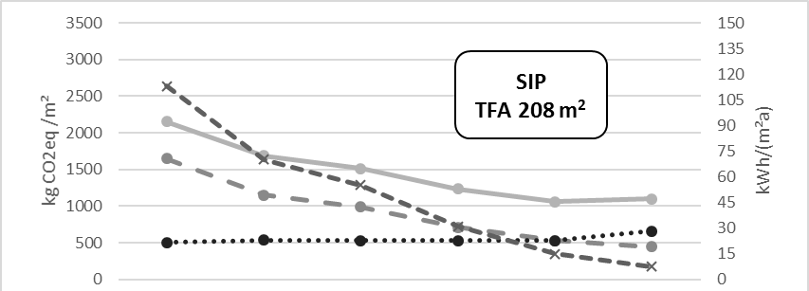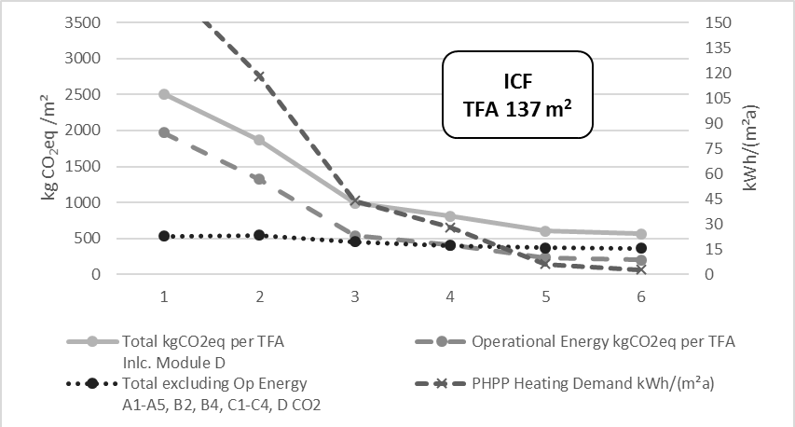
Figure 3: kgCO2eq for timber building on slab. Even at half the operational energy of a Certified Passive House the additional materials just start to approach the operational energy of the building. Case 1 is NZ building code minimum; Case 2-4 are steps along to Case 5 which is the certified Passive House performance and Case 6 with half of the certified Passive House heating demand.
For the three specific Certified Passive House buildings explored the overall LCA kgCO2e continued to reduce as heating demand reduced to certified PH level. This continued even below 7 kWh/m²/year of heating demand (i.e. case 6 which is half the operational heating energy of a Certified Passive House) for the Timber and ICF building. For the SIP building in the warmer Hamilton climate the overall LCA kgCO2e slightly increased at 7 kWh/m²/year of heating demand when compared to the certified performance level of 15 kWh/m²/year of heating demand.
  - Conclusion
The conclusion we draw from these three cases is the ecological optimum (solely in kgCOe) for these buildings, given NZ embodied energy and ‘green’ electrical grid, is below 7 kWh/m²/year of heating for the timber and ICF building and close to 15 kWh/m²/year of heating demand for the SIP building. For other countries with lower embodied energy and less renewable energy in the electrical grids the ecological optimum is likely below these values of heating demand. Plausible reasons for the SIP building being optimised at the higher operation energy demand include the higher embodied energy in the insulation (XPS was selected to represent the SIP core insulation), the lower increase in timber content (which stores CO2 while in the use phase), the relatively poor heat loss form factor, and the warmer climate of its location. For most climate regions in NZ with lower embodied energy insulations the ecological optimum (in kgCO2e over the buildings life cycle) is likely to be lower than half the certified Passive House performance level.

  - PHPP linkage to LCAQuick
The PHPP variants file is linked to the LCAQuick Excel file to provide the energy consumptions, areas (by U-value and glass/frame), PV panel parameters, and the variable thicknesses used on the variants sheets. The linkage is similar to the methods used to link the PHPP variants file to the EnerPHit sheets supplied with the PHPP software. Tables are built manually in LCAQuick to match the window material quantities to the variants. Then the layers are built/selected in LCAQuick to use the variants materials thicknesses. This results in two linked files that allow changing the variant in LCAQuick and visualizing the resulting LCA impacts. One caution is to be very careful when linking the Variants materials to the LCA materials that you differentiate between the area based and volume-based materials.

References
[Dowdell 2016] Dowdell, D.; Berg, B: New Zealand whole-building whole-of-life framework: An overview, BRANZ Study Report SR349, 2016
[2019 Frischknecht] Frischknecht, et. al.: Comparison of the environmental assessment of an identical office building with national methods, Sustainable Built Environment Conference 2019. (To be published)

Summary
Demonstration of the integration between the Microsoft Excel based LCAQuick and PHPP which allows simultaneous calculation of the Life Cycle Assessment (LCA). This allows the designer to optimize the building to minimize energy and multiple environmental indicators simultaneously.

Annex 72 “Assessing life cycle related environmental impacts caused by buildings”.

