Site Photos

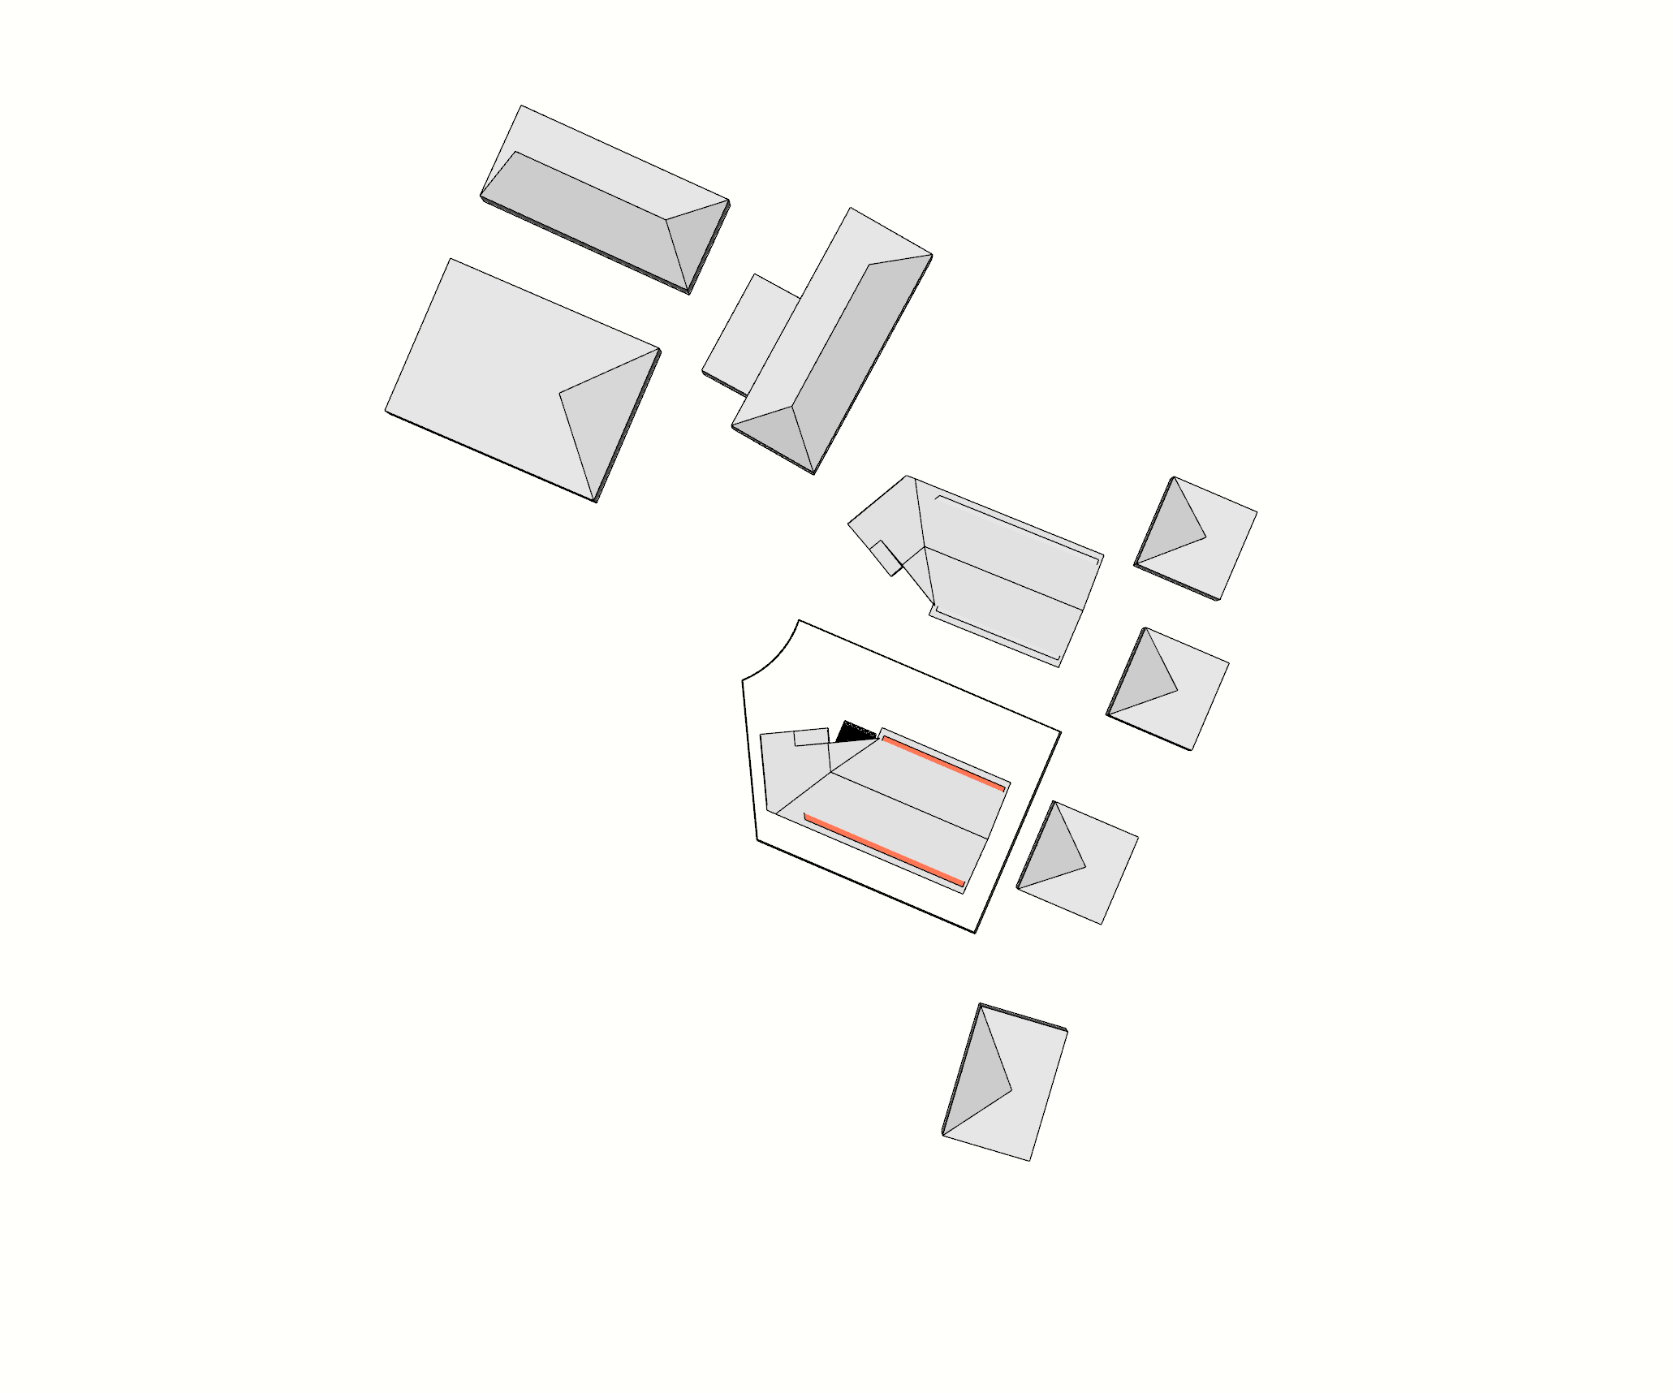

Screenshot of designPH showing all the buildings modelling for shading